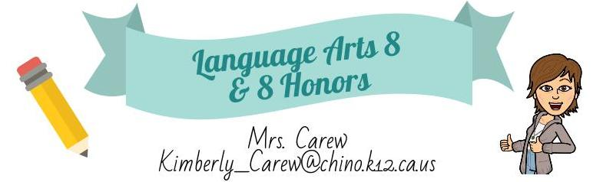

Welcome to eighth grade Language Arts. This is my nineteenth year of teaching English. I am excited about the new school year, and I am looking forward to a productive, fun year!

Focusing on the four components of Language Arts - Reading, Writing, Speaking, and Listening - the skills you learn in this class will lay the foundation for your success in high school, college, and beyond.

By the end of this year, you will:

- Demonstrate and strengthen your ability to write in a variety of writing forms and genres including argumentative, informational, literary analysis, and narrative.

- Become a close reader, identifying, and analyzing the important features of different texts.

- Gain confidence as an effective presenter in front of your peers.

- Utilize critical thinking and communication skills in formal and informal discussions.

Classroom Expectations

To ensure that we maintain a productive, respectful, and safe environment for learning. Students must adhere to school-wide behavioral expectations: Be Safe, Be Responsible, and Be Respectful.

Recommended Class Materials

- Blue/Black Pens/Red pens
- Pencils
- Canyon Hills Junior High Agenda
- Highlighters
- Colored Pencils
- Three Ring binder
- CHARGED Chromebook

Absent/Late Work Policy

Students who are absent, are allowed the same number of days to make up the missed assignment as the days they were absent. If a student is absent one day, they have one day to make up the work they missed. It is the student’s responsibility to check their agenda and Google Classroom for any and all assignments. All assignments will be uploaded to Google Classroom unless stated otherwise.

Late work:

Gate/Honors Classes - No late work will be accepted.

Language Arts 8 - Each day an assignment is late will result in a ten percent deduction, unless stated otherwise in a student’s IEP/504 Plan.

Cheating/Plagiarism

Cheating and plagiarism will not be tolerated in this class. If a student is caught cheating from someone else’s work or plagiarizing, a zero will be given to the student and parents will be notified. Cheating includes copying off classmates, CHAT GPT, and all A.I. tools. Please see the Academic Honesty Policy in Canyon Hills Agenda.

Cell Phones/Electronics

Cell phones may not be used during the school day. Please see Canyon Hills Handbook for details.

Google Classroom

This year, students will be expected to regularly access our class’s Google Classroom, which will be used to access and submit assignments, assessments, and other important class materials. Students are expected to have a Chromebook with them that was supplied by Canyon Hills, every day. In case of connectivity issues, students should still come prepared to school with physical paper and writing utensils each day.

After School Hours

I am available before school for any guidance or assistance you may need on any assignments. Students need to let me know if they are planning to come after school. There may be some occasions where I have meetings, I have to attend, in which I will let students know I will not be available.

Food Policy

Any sugary drinks (Gatorade, soda, juice) must be finished outside the classroom. GUM IS NEVER PERMITTED AT SCHOOL. Water is acceptable in the classroom.

Grading Policy

Grades are based on cumulative points and can be viewed on the Aeries Parent Portal.

- Assessments/Essays/Projects 60%
- Classwork/Homework &
Essay Rough Drafts/Journals/
Agenda/Notes 40%

--------------------------------------------------------------------------------------------------------------------------------------

I have read and agreed to the syllabus guidelines stated by my teacher.

Parent Signature_________________________ Date _________________

Parent Name ____________________________

Student Signature ________________________ Date _________________

Student Name ___________________________

